**DAY9** **NAME : VISWAS GA**

**ROLL NO : 727721eucs184**

**CLASS EXERCISE 1 :**

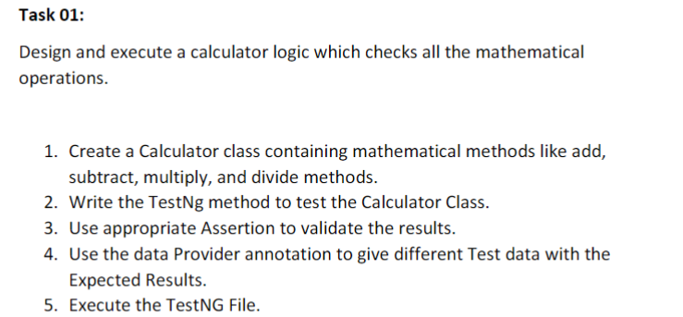

**CODE :**

package com.day9;

import org.testng.annotations.Test;

import org.testng.annotations.DataProvider;

public class CE_1 {

@Test(dataProvider = "dp",priority = 1)

public void add(Integer n1, Integer n2)

{

System.out.println("Addition "+(n1+n2));

}

@Test(dataProvider = "dp",priority = 2)

public void sub(Integer n1, Integer n2)

{

System.out.println("Subtraction "+ (n1-n2));

}

@Test(dataProvider = "dp",priority = 3)

public void mul(Integer n1, Integer n2)

{

System.out.println("Multiplication "+(n1*n2));

}

@Test(dataProvider = "dp",priority = 4)

public void div(Integer n1, Integer n2)

{

System.out.println("Division "+(n1/n2));

}

@DataProvider

public Object[][] dp() {

return new Object[][] {

new Object[] { 1, 99 },

new Object[] { -2, -20 },

};

}

}

**OUTPUT :**

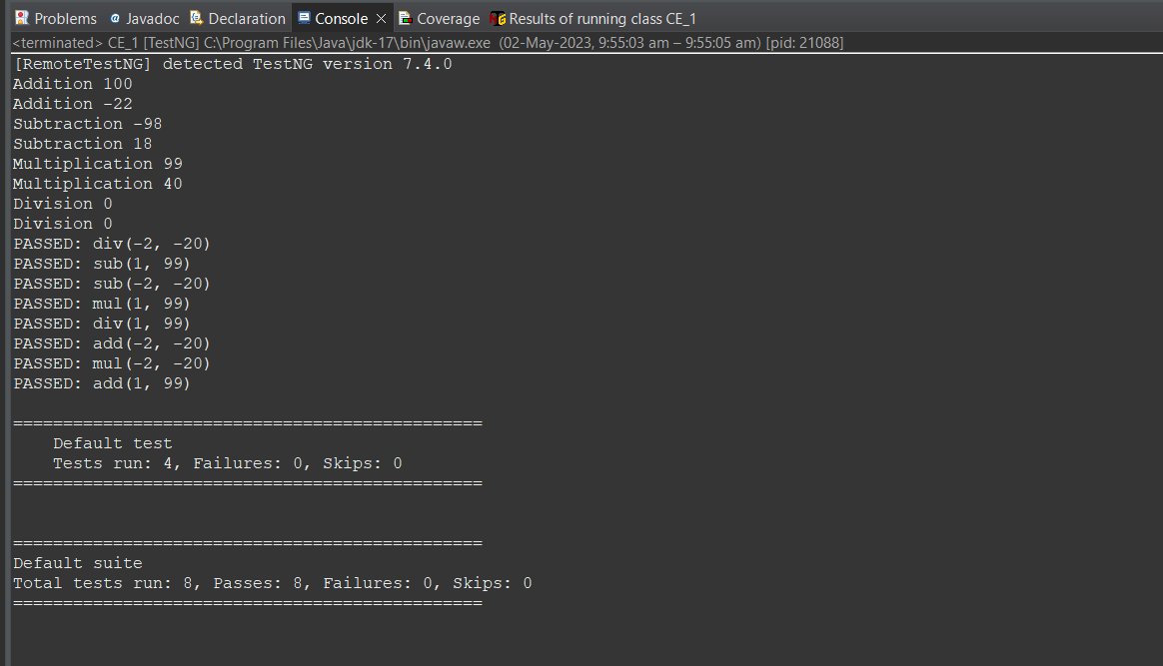

**CLASS EXERCISE 2 AND 3 :**

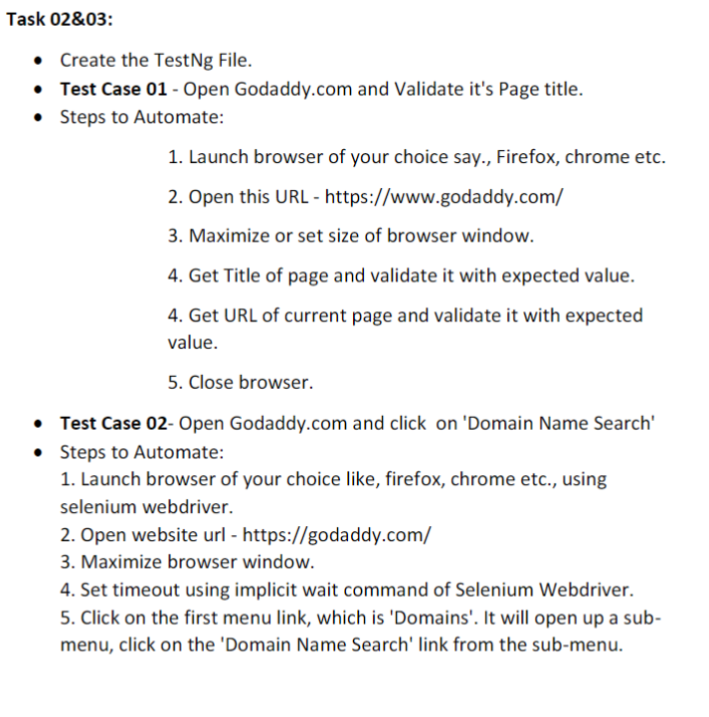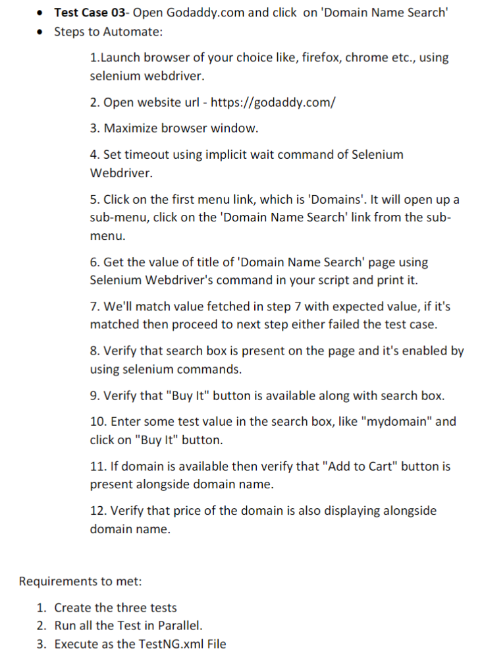

**CODE :**

package com.day9;

import org.testng.annotations.Test;

import io.github.bonigarcia.wdm.WebDriverManager;

import org.testng.annotations.BeforeMethod;

import java.util.concurrent.TimeUnit;

import org.openqa.selenium.By;

import org.openqa.selenium.WebDriver;

import org.openqa.selenium.WebElement;

import org.openqa.selenium.chrome.ChromeDriver;

import org.openqa.selenium.chrome.ChromeOptions;

import org.testng.Assert;

import org.testng.annotations.AfterMethod;

public class CE_2 {

WebDriver driver;

*@Test*(groups="SmokeTest")

public void validate() {

ChromeOptions co = new ChromeOptions();

co.addArguments("--remote-allows-origins=*");

WebDriverManager.*chromedriver*().setup();

driver = new ChromeDriver(co);

driver.get("https://www.godaddy.com/");

driver.manage().window().maximize();

String actualTitle = driver.getTitle();

String expectedTitle = "Domain Names, Websites, Hosting & Online Marketing Tools - GoDaddy IN";

Assert.*assertEquals*(actualTitle, expectedTitle);

String actualUrl = driver.getCurrentUrl();

String expectedUrl = "https://www.godaddy.com/en-in";

Assert.*assertEquals*(actualUrl, expectedUrl);

}

*@Test*(groups="RegressionTestCase")

public void search() throws InterruptedException

{

ChromeOptions co = new ChromeOptions();

co.addArguments("--remote-allows-origins=*");

WebDriverManager.*chromedriver*().setup();

driver = new ChromeDriver(co);

driver.get("https://www.godaddy.com/");

driver.manage().window().maximize();

Thread.*sleep*(3000); driver.findElement(By.*xpath*("/html/body/header/div/section/div/div[1]/nav/div[2]/div[1]/ul/li[1]/button")).click();

Thread.*sleep*(3000);

driver.findElement(By.*linkText*("Domain Name Search")).click();;

}

*@Test*(groups="RegressionTestCase")

public void case3() throws InterruptedException

{

ChromeOptions co = new ChromeOptions();

co.addArguments("--remote-allows-origins=*");

WebDriverManager.*chromedriver*().setup();

driver = new ChromeDriver(co);

driver.get("https://www.godaddy.com/");

driver.manage().window().maximize();

Thread.*sleep*(3000);

driver.findElement(By.*xpath*("/html/body/header/div/section/div/div[1]/nav/div[2]/div[1]/ul/li[1]/button")).click();

Thread.*sleep*(3000);

driver.findElement(By.*linkText*("Domain Name Search")).click();

Thread.*sleep*(3000);

String title = driver.getTitle();

System.***out***.println(title);

Assert.*assertEquals*(title, "GoDaddy Domain Search - Buy and Register Available Domain Names");

Thread.*sleep*(5000);

boolean isSearchBoxPresent = driver.findElement(By.*name*("searchText")).isDisplayed();

Assert.*assertEquals*(isSearchBoxPresent, true);

}

*@BeforeMethod*

public void beforeMethod(){

}

*@AfterMethod*

public void afterMethod() {

driver.close();

}

}

**CODE (CE_2_3.xml) :**

<?xml version="1.0" encoding="UTF-8"?>

<!DOCTYPE suite SYSTEM "https://testng.org/testng-1.0.dtd">

<suite parallel="methods" name="Suite">

<test name="Test">

<classes>

<class name="com.day9.CE_2"/>

</classes>

</test> <!-- Test -->

</suite> <!-- Suite -->

**OUTPUT :**

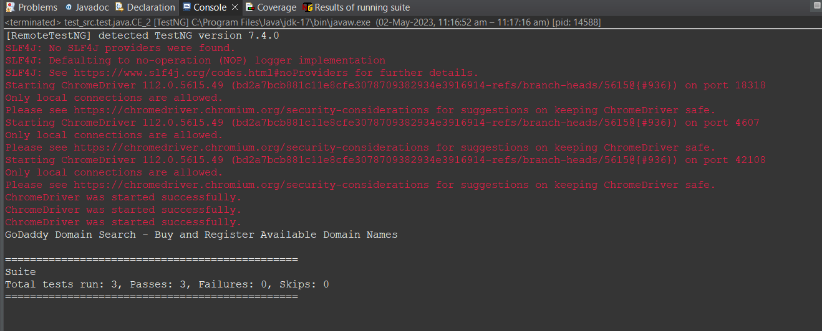

**CLASS EXERCISE 4 :**

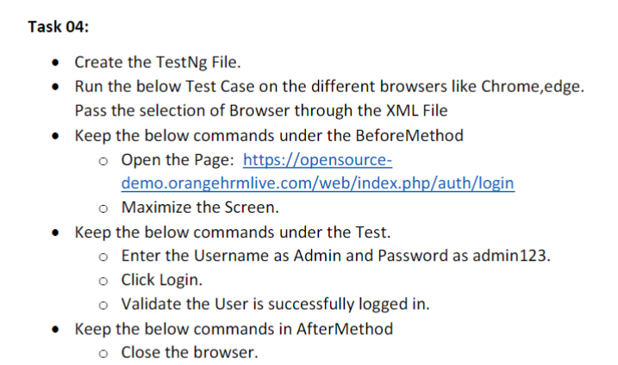

**CODE :**

package com.day9;

import org.testng.annotations.Test;

import io.github.bonigarcia.wdm.WebDriverManager;

import org.testng.annotations.BeforeMethod;

import org.testng.annotations.Parameters;

import org.openqa.selenium.By;

import org.openqa.selenium.Keys;

import org.openqa.selenium.WebDriver;

import org.openqa.selenium.WebElement;

import org.openqa.selenium.chrome.ChromeDriver;

import org.openqa.selenium.chrome.ChromeOptions;

import org.openqa.selenium.edge.EdgeDriver;

import org.openqa.selenium.edge.EdgeOptions;

import org.testng.Assert;

import org.testng.annotations.AfterMethod;

public class CE_4 {

WebDriver driver;

*@Test*

public void f() throws InterruptedException

{

Thread.*sleep*(3000);

WebElement userName = driver.findElement(By.*xpath*("/html/body/div/div[1]/div/div[1]/div/div[2]/div[2]/form/div[1]/div/div[2]/input"));

userName.sendKeys("Admin",*Keys*.***ENTER***);

WebElement passWord = driver.findElement(By.*xpath*("/html/body/div/div[1]/div/div[1]/div/div[2]/div[2]/form/div[2]/div/div[2]/input"));

passWord.sendKeys("admin123");

driver.findElement(By.*xpath*("/html/body/div/div[1]/div/div[1]/div/div[2]/div[2]/form/div[3]/button")).click();

Thread.*sleep*(3000);

String successfulLogin = driver.findElement(By.*xpath*("/html/body/div/div[1]/div[1]/header/div[1]/div[1]/span/h6")).getText();

Assert.*assertEquals*(successfulLogin, "Dashboard");

}

*@Parameters*({"browser"})

*@BeforeMethod*

public void beforeMethod(String browser1) //runtime parameter...can be same name as browser

{

if(browser1.equals("chrome"))

{

ChromeOptions co = new ChromeOptions();

co.addArguments("--remote-allows-origins=*");

WebDriverManager.*chromedriver*().setup();

driver = new ChromeDriver();

driver.get("https://opensource-demo.orangehrmlive.com/web/index.php/auth/login");

driver.manage().window().maximize();

}

else if(browser1.equals("edge"))

{

EdgeOptions co = new EdgeOptions();

co.addArguments("--remote-allows-origins=*");

WebDriverManager.*edgedriver*().setup();

driver = new EdgeDriver();

driver.get("https://opensource-demo.orangehrmlive.com/web/index.php/auth/login");

driver.manage().window().maximize();

}

}

*@AfterMethod*

public void afterMethod() {

driver.close();

}

}

**CODE (CE_4.xml) :**

<?xml version="1.0" encoding="UTF-8"?>

<!DOCTYPE suite SYSTEM "https://testng.org/testng-1.0.dtd">

<suite parallel="false" name="Suite">

<test name="Test">

<parameter name="browser" value="chrome"></parameter>

<classes>

<class name="com.day9.CE_4"/>

</classes>

</test> <!-- Test -->

</suite> <!-- Suite -->

**OUTPUT :**

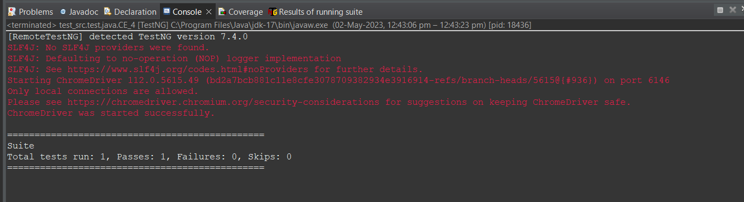

**CLASS EXERCISE 5 :**

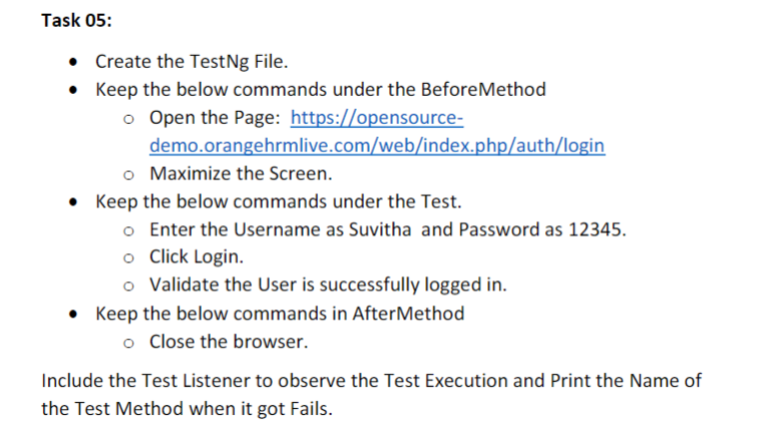

**CODE :**

package com.day9;

import org.testng.annotations.Test;

import io.github.bonigarcia.wdm.WebDriverManager;

import org.testng.annotations.BeforeMethod;

import org.testng.annotations.Parameters;

import org.openqa.selenium.By;

import org.openqa.selenium.Keys;

import org.openqa.selenium.WebDriver;

import org.openqa.selenium.WebElement;

import org.openqa.selenium.chrome.ChromeDriver;

import org.openqa.selenium.chrome.ChromeOptions;

import org.openqa.selenium.edge.EdgeDriver;

import org.openqa.selenium.edge.EdgeOptions;

import org.testng.Assert;

import org.testng.annotations.AfterMethod

public class CE_5 {

WebDriver driver;

@Test

public void f() throws InterruptedException

{

Thread.sleep(3000);

WebElement userName = driver.findElement(By.xpath("/html/body/div/div[1]/div/div[1]/div/div[2]/div[2]/form/div[1]/div/div[2]/input"));

userName.sendKeys("Suvitha",Keys.ENTER);

WebElement passWord = driver.findElement(By.xpath("/html/body/div/div[1]/div/div[1]/div/div[2]/div[2]/form/div[2]/div/div[2]/input"));

passWord.sendKeys("12345");

driver.findElement(By.xpath("/html/body/div/div[1]/div/div[1]/div/div[2]/div[2]/form/div[3]/button")).click();

Thread.sleep(3000);

String successfulLogin = driver.findElement(By.xpath("/html/body/div/div[1]/div[1]/header/div[1]/div[1]/span/h6")).getText();

Assert.assertEquals(successfulLogin, "Dashboard");

}

@Parameters({"browser"})

@BeforeMethod

public void beforeMethod(String browser1) //runtime parameter...can be same name as browser

{

if(browser1.equals("chrome"))

{

ChromeOptions co = new ChromeOptions();

co.addArguments("--remote-allows-origins=*");

WebDriverManager.chromedriver().setup();

driver = new ChromeDriver();

driver.get("https://opensource-demo.orangehrmlive.com/web/index.php/auth/login");

driver.manage().window().maximize();

}

else if(browser1.equals("edge"))

{

EdgeOptions co = new EdgeOptions();

co.addArguments("--remote-allows-origins=*");

WebDriverManager.edgedriver().setup();

driver = new EdgeDriver();

driver.get("https://opensource-demo.orangehrmlive.com/web/index.php/auth/login");

driver.manage().window().maximize();

}

}

@AfterMethod

public void afterMethod() {

driver.close();

}

}

**CODE (ListenerCE_5.java) :**

package com.day9;

import org.testng.ITestContext;

import org.testng.ITestListener;

import org.testng.ITestResult;

public class ListenerCE_5 implements ITestListener

{

public void onFinish(ITestContext context) {

// **TODO** Auto-generated method stub

System.***out***.println("onFinish");

}

public void onStart(ITestContext context) {

// **TODO** Auto-generated method stub

System.***out***.println("onStart");

}

public void onTestFailedButWithinSuccessPercentage(ITestResult result) {

// **TODO** Auto-generated method stub

System.***out***.println("onTestFailedButWithinSuccessPercentage : " + result.getName());

}

public void onTestFailedWithTimeout(ITestResult result) {

// **TODO** Auto-generated method stub

System.***out***.println("onTestFailedWithTimeout : " + result.getName());

}

public void onTestFailure(ITestResult result) {

// **TODO** Auto-generated method stub

System.***out***.println("onTestFailure : " + result.getName());

}

public void onTestSkipped(ITestResult result) {

// **TODO** Auto-generated method stub

System.***out***.println("onTestSkipped : " + result.getName());

}

public void onTestStart(ITestResult result) {

// **TODO** Auto-generated method stub

System.***out***.println("onTestStart : " + result.getName());

}

public void onTestSuccess(ITestResult result) {

// **TODO** Auto-generated method stub

System.***out***.println("onTestSuccess : " + result.getName());

}

}

**CODE (CE_5.xml) :**

<?xml version="1.0" encoding="UTF-8"?>

<!DOCTYPE suite SYSTEM "https://testng.org/testng-1.0.dtd">

<suite parallel="false" name="Suite">

<listeners>

<listener class-name="com.day9.ListenerCE_5"></listener>

</listeners>

<test name="Test">

<parameter name="browser" value="chrome"></parameter>

<classes>

<class name="com.day9.CE_5"/>

</classes>

</test> <!-- Test -->

</suite> <!-- Suite -->

**OUTPUT :**

